Physical Activity  https://www.gov.uk/government/publications/uk-physical-activity-guidelines  http://www.breastmilk.com/  http://www.nhs.uk/conditions/pregnancy-and-baby/pages/expressing-storing-breast-milk.aspx  http://www.nhs.uk/Conditions/pregnancy-and-baby/Pages/benefits-breastfeeding.aspx  https://www.unicef.org.uk/babyfriendly  http://www.bhfactive.org.uk/early-years/index.html  http://raisingchildren.net.au/articles/movement_babies.html  http://www.bhfactive.org.uk/early-years/index.html  http://raisingchildren.net.au/articles/movement_babies.html  Oral Health  Sugar Consumption  https://www.bda.org/public/sugar-and-children%E2%80%99s-oral-health-top-tips  Healthy Snacks and drinks  http://www.child-smile.org.uk/parents-and-carers/birth-to-3-years-old/drinking-from-a-cup.aspx  Dental Care  http://www.nhs.uk/Livewell/dentalhealth/Pages/Careofkidsteeth.aspx  http://www.nhs.uk/Livewell/dentalhealth/Pages/Teethcleaningguide.aspx  https://www.healthychildren.org/English/healthy-living/oral-health/Pages/default.aspx?gclid=CJCKhtSsydICFQxmGwod01kJTw |  | Breast Feeding & Breast Milk.  http://www.breastmilk.com/  https://www.unicef.org.uk/babyfriendly  http://www.nhs.uk/conditions/pregnancy-and-baby/pages/expressing-storing-breast-milk.aspx  http://www.nhs.uk/Conditions/pregnancy-and-baby/Pages/benefits-breastfeeding.aspx

Green Wrythe Primary School
Healthy Early Years Newsletter
Spring 2020

 |  | Healthy Eating  http://www.nhs.uk/start4life  http://www.nhs.uk/Tools/Pages/Toolslibrary.aspx?Tag=Healthy+eating  http://www.firststepsnutrition.org/newpages/Early_Years/eating_well-early_years.html  http://www.parents.com/toddlers-preschoolers/feeding/healthy-eating/break-your-kids-bad-food-habits  https://www.actionforchildren.org.uk/media/9750/eat-well-practical-guide-final-check.pdf  Healthy start  http://www.healthystart.nhs.uk/  Free Milk Fruit and Vegetables  https://www.nidirect.gov.uk/articles/free-milk-fruit-vegetables-and-vitamins |  | 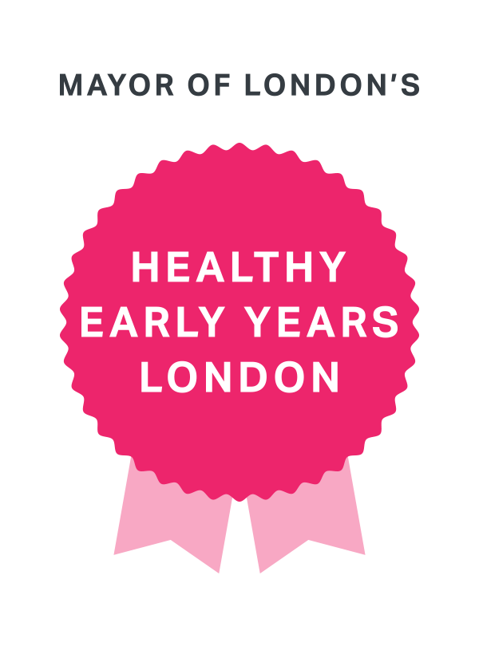
Behaviour Support  Attachment  https://www.helpguide.org/articles/secure-attachment/attachment-issues-and-reactive-attachment-disorders.htm  Sleep disorders  http://www.nhs.uk/Livewell/Childrenssleep/Pages/howmuchsleep.aspx  Speech and Language  http://www.lnwh.nhs.uk/services/harrow-community-services/speech-and-language-therapy-paediatric/  http://www.foundationyears.org.uk/files/2011/10/EveryChild_a_Talker_consultants_guidance11.pdf |  |  |  | Immunisation  http://www.nhs.uk/conditions/vaccinations/Pages/childhood-vaccination-schedule.aspx  Independence and self care  http://articles.extension.org/pages/26436/ways-to-encourage-self-help-skills-in-children  http://www.nurseryworld.co.uk/nursery-world/news/1098703/parents-guide-developing-independence  Potty Training  http://www.eric.org.uk/  http://www.nhs.uk/Conditions/pregnancy-and-baby/Pages/potty-training-tips.aspx
You are entitled to Healthy Start vouchers if you are at least 10 weeks pregnant or have a child under four years of age and you or your family get one of the following:
- Income Support
- Income-based Jobseeker’s Allowance
- Income-related Employment and Support Allowance
- Child Tax Credit (but not Working Tax Credit unless your family is receiving Working Tax Credit run-on only) and an annual family income of £16,190 or less
- Universal Credit (with a family take home pay of £408 or less per month)
Working Tax Credit run-on is the Working Tax Credit you receive in the four weeks immediately after you have stopped working for 16 hours or more per week.

